**CONTROL SYSTEMS ENGINEERING MtE - 328**

**Sixth Semester Spring 2023**

**Assignment 04**

**Name: Muhammad Ali**

**Reg.no: 19pwcse1801 (Repeater)**

**Department: Computer System Engineering**

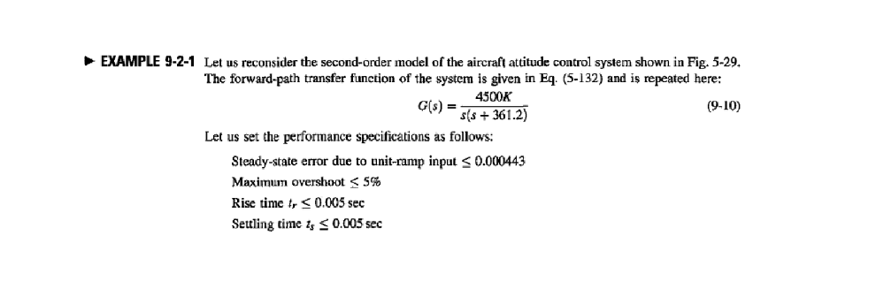

**MATLAB code: -**

clc

clear all

% gain and calculated values

K = 181.17

Kp = 1;

Kd = 0.0017;

Ki = 0;

s= tf('s');

% Given Transfer Function

TF = (4500*K)/(s^2 + 361.2*s+0);

step(TF/s); %Ramp response

t = 0:0.1:10;

controller = pid(Kp,Ki,Kd) %pid controller

UNIT_FD = feedback(controller*TF,1) %unity feedback

linearSystemAnalyzer(UNIT_FD) %analyzer to examine required specification

**Result: -**

K =

181.1700

controller =

Kp + Kd * s

with Kp = 1, Kd = 0.0017

Continuous-time PD controller in parallel form.

UNIT_FD =

1386 s + 815265

---------------------

s^2 + 1747 s + 815265

Continuous-time transfer function.

>>

**Analyzer view of rise,settling time: -**

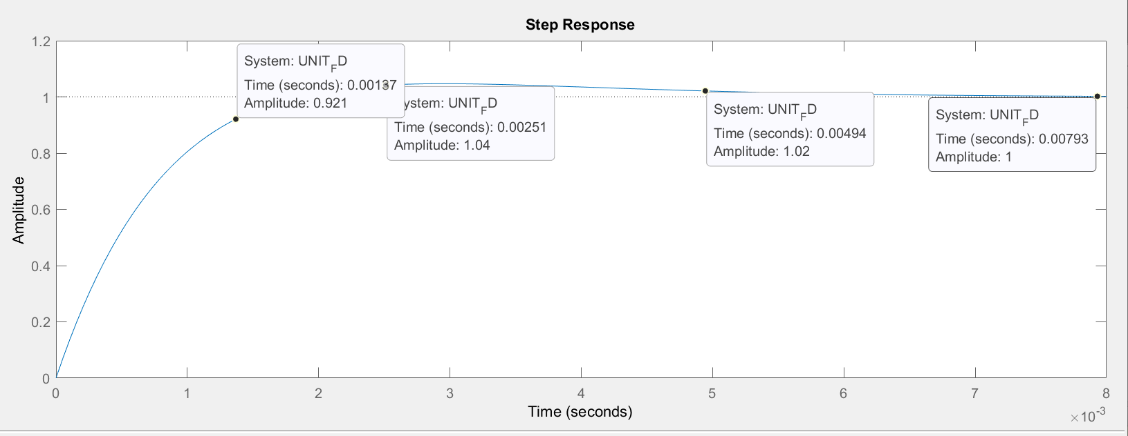

Maximum overshoot is 0.46% and steady state error is 0.0001<0.00044

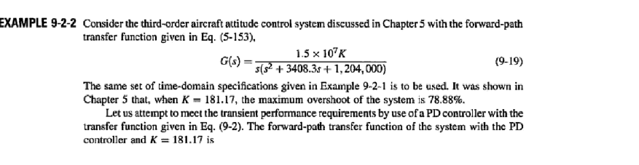

**MATLAB code: -**

clc

clear all

K = 181.17

s= tf('s');

%Given Transfer Function

TF = (15000000*K)/(s^3 + 3408.3*s^2+ 0*s + 1204000);

step(TF/s); %Ramp response

pidTuner(TF,'PD')

Pidtuner: -

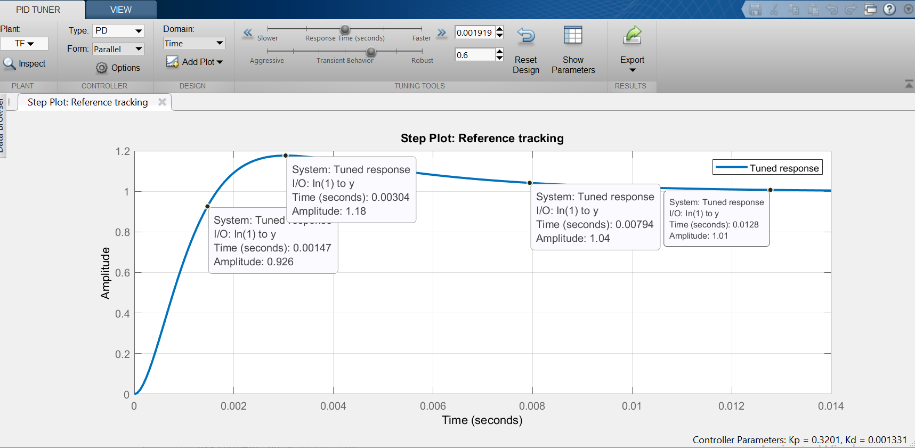

Overshoot is 7%, steady state error is 0.00026 and rise, settling are shown in the above PD TUNER.